Customer Management Platform – User Manual

1/ Click “Client Portal” in www.interact-hkg.com or direct enter http://interact-hkg.com/cdb/index.asp
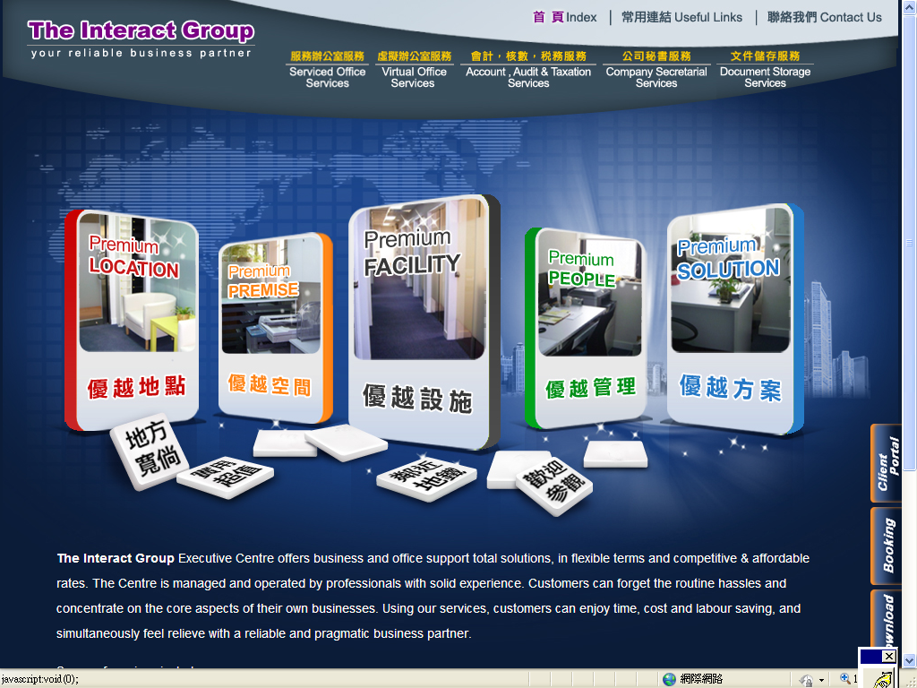

2. Enter the email address and password to login your account.
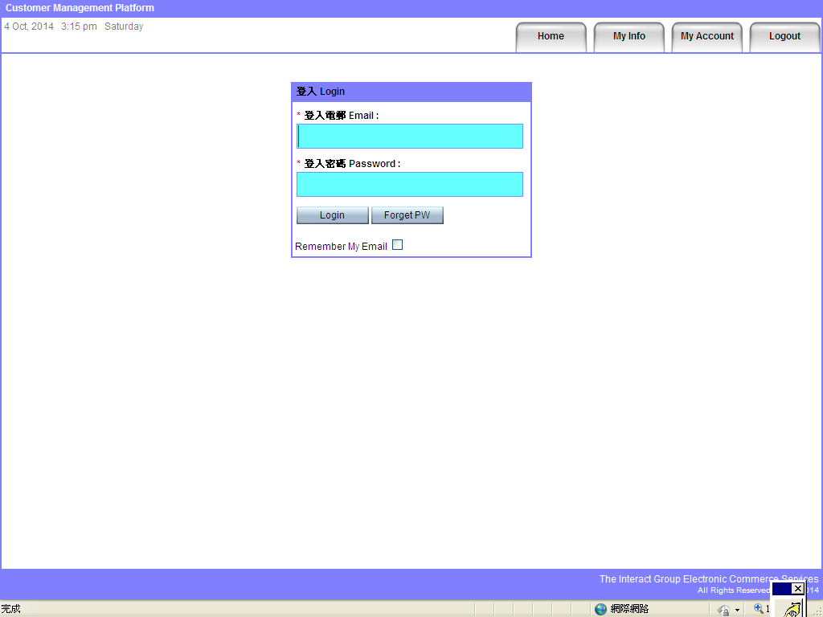

3. The Home button will navigate you to our website.
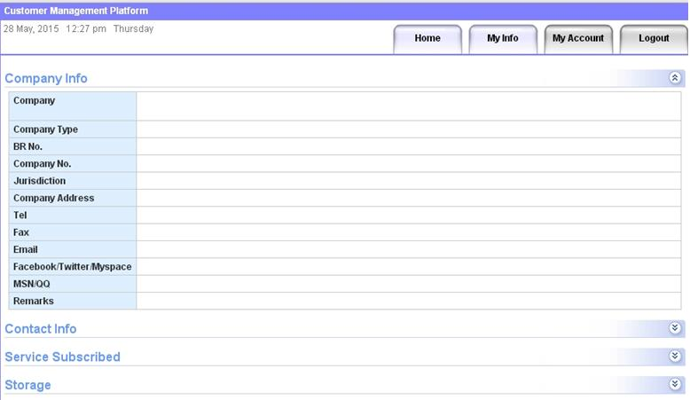

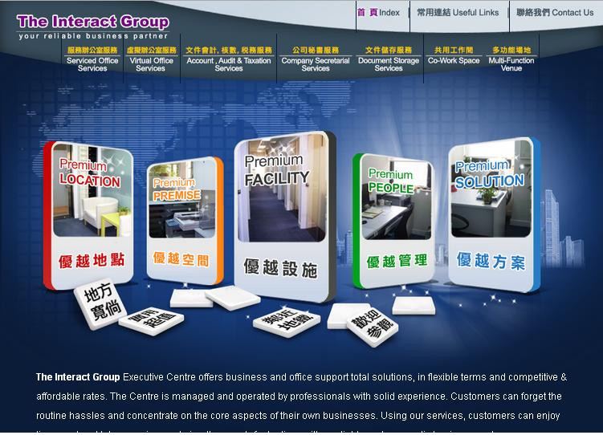

4. You can view all your company information under My Info → Company Info.
For first-time users, please check your company information.
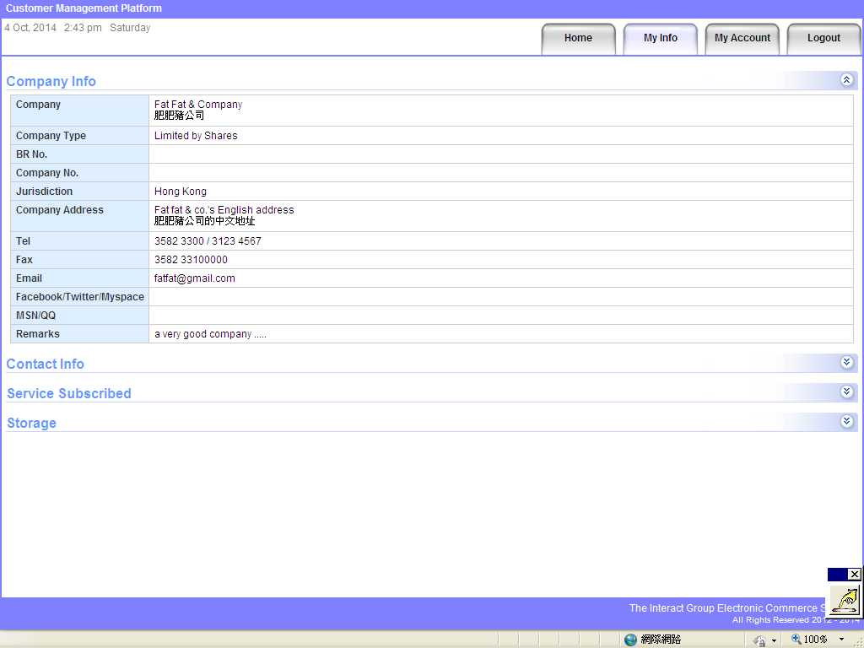

5. You can view all your company contact information under My Info → Contact Info.
For first-time users, please check your company information.
We have set a dummy email address for those who do not provide one for us. If you want to add one, please inform us.
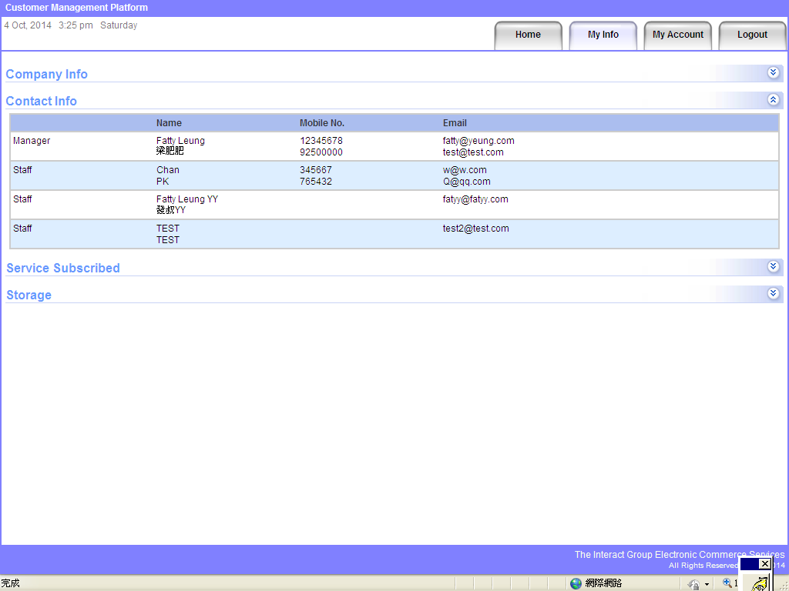

6. All the subscribed services will be listed under My Info → Service Subscribed.
Please check the expiry date and renew accordingly.
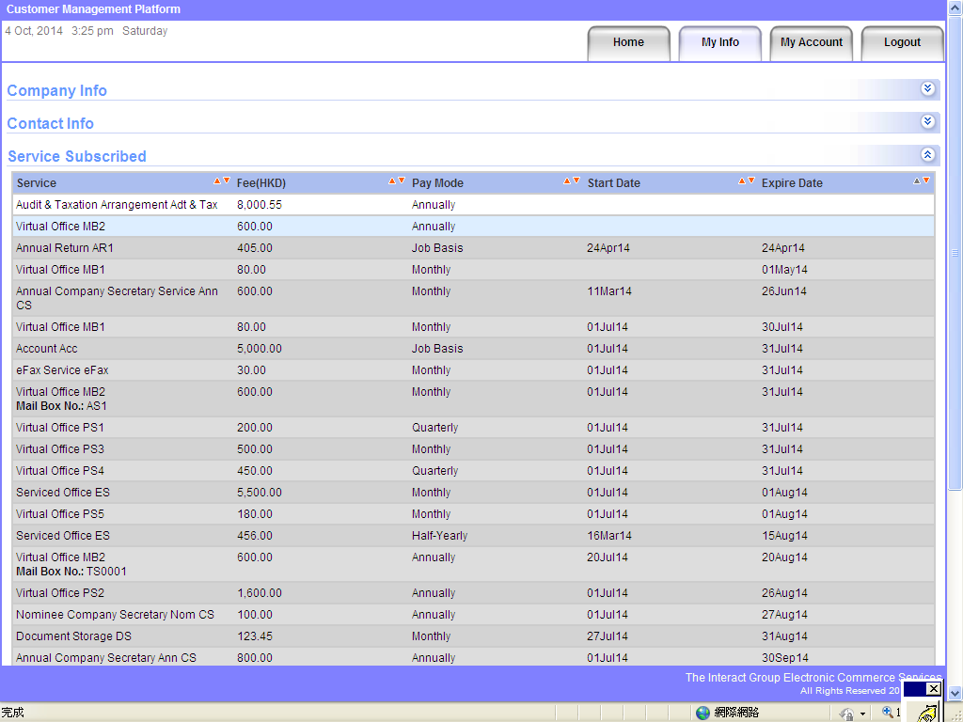

7. If you have subscribed the services with document storage and mails, you can view details of stuff left; amount of prepayment & deposit and miscellaneous surcharges on Photocopy, IDD, air-cond, courier, etc. can also be reviewed under My Info → Storage.
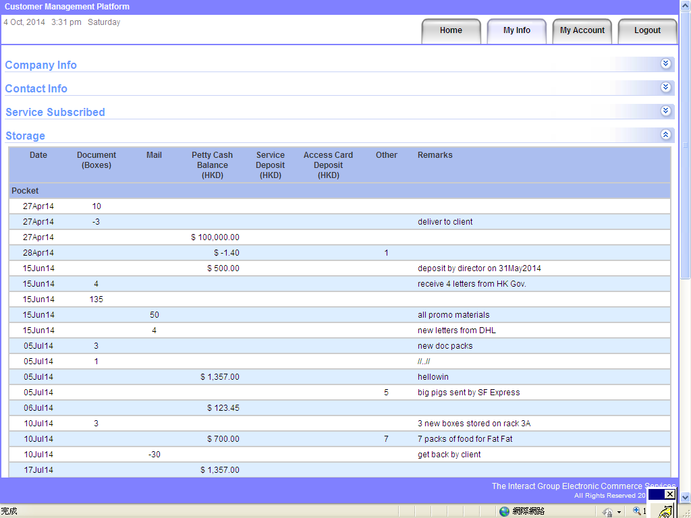

8. You may edit your personal information under My Account.
